POI 2

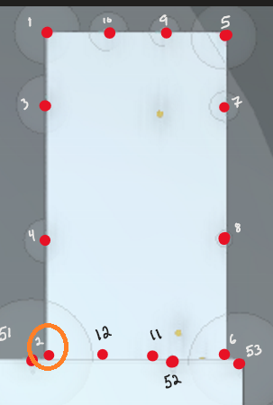

POI 2 incorrectly reads not extended.

We might be able to overlook these and not call them corner points and instead call them edge points. The edge points allow for extended flag to be pulled.

POI 9-10:

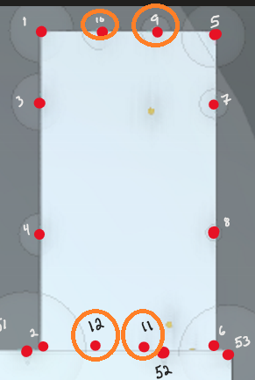

POI 9 pulls extended and slope but calculation is incorrect. **@Ron Geyer**

POI 10 pulls extended and slope but calculation is incorrect. **@Ron Geyer**

POI 13 [fixed]:

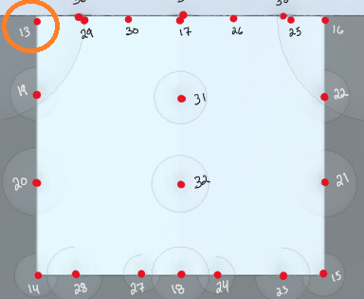

Point should’ve pulled extended but was placed poorly.

I adjusted the type to gable edge – eave and was able to grab extended flag

I updated the GUID of the point in my records and re-ran analysis

The point correctly resolved

POI 17 [fixed]:

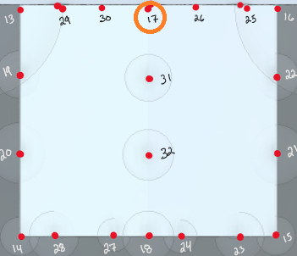

Point placed as Gable Corner – Ridge

Adjusted to Gable Edge – Ridge

POI 23-24, 27-28, 41-44,54-57:

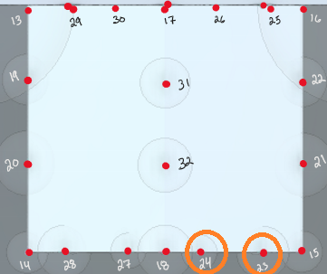

Points pull extended and slope but have multiplicative value of 1 for some reason

**@Ron Geyer** please review the flow for Gable Edge – Sloped points. Should result in **Eq G**

POI 52

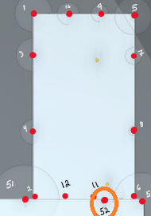

Should pull GRN, looks like it only pulls maybe N? **@Ron Geyer**

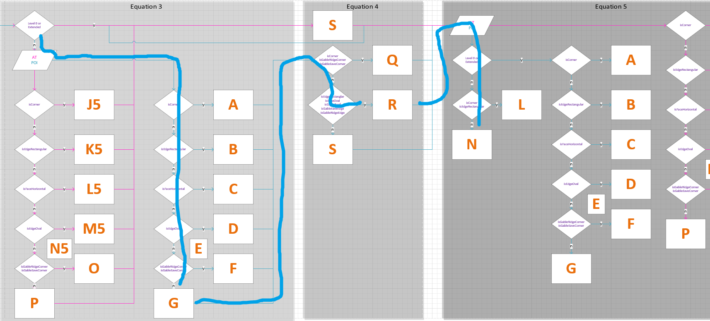

POI MAP:

